# Chapter – 3 System Management And Planning

3.1 : Feasibility Study

3.1.1 : Technical Study

3.1.2 : Economical Study

3.1.3 : Operational study

3.2 : Hardware and Software Requirement

3.3 : System Planning

3.3.1 : Work Break Down Structure

3.3.2 : GANTT Chart

3.4 : Process Model

# 3.1 Feasibility Study

## 3.1.1 Technical Study :

* + Neo Banks succeed by using modern technology like mobile apps and the internet.
  + They are safe and easy to use because they have smart systems and tools like data analysis.
  + They can grow and adapt because they keep improving their technology and follow rules to protect your money and information.

How our system is technically Feasible ?

* + Digital Infrastructure : Assess the availability of essential digital resources and networks.
  + Data Security : Ensure customer information and transactions are protected by robust security measures.
  + Customer Support ChatBots : Enhance customer support with AI-driven chatbots and virtual assistants
  + Real-Time Transactions : Enable real-time transaction processing and settlement.
  + Cross-platform Compatibility : Make services available across different operating systems and devices.
  + Payment Gateways : Integrate various payment methods, including cards, digital wallets, and international transfers.
  + Testing and Quality Assurance : Identify and fix technical issues with rigorous testing and quality assurance procedures.
  + Regulatory Compliance : Adapt to changing financial regulations and data protection laws.

## 3.1.2 Economic Feasibility

* Economic Feasibility is a type of feasibility study that determines whether a software project will be financially beneficial to an organization.
* It evaluates the cost of the software development against the ultimate income or benefits gained from the developed system.
* There must be scope for profit after the successful completion of the project.

Why our system economically feasible ?

* Save Expenses: Our system can save on expenses such as physical branches, tellers, and associated infrastructure. This cost advantage can contribute to their economic viability.
* Advance Technology: We will often use advanced technology and automation to streamline operations, reducing the need for a large workforce. This can lead to further cost savings.
* Accommodate Changes: Due to economic feasibility, we can estimate and make changes according to the budget.
* Availability: Neo banks can be more accessible, making banking available to more people.

## 3.1.3. Operational Feasibility

* Operational feasibility for neobank websites means they should work smoothly and efficiently for customers.
* In simple terms, it's about making sure the website is easy to use and all the banking functions, like checking your balance or transferring money, work without problems.

Why our system operationally feasible?

* User-Friendly: Neo banks focus on creating intuitive, user-friendly websites and apps, making it easy for customers to manage their finances
* Accessibility: Customers can access their accounts and perform transactions 24/7 from the convenience of their devices.
* Efficient Customer Support: Neo banks can provide efficient online customer support, addressing issues promptly.

# 3.2 Hardware and Software Requirements

## 3.2.1 Hardware Requirement :

* Server-Side Requirements :
  + - Processor 3.0 GHz
    - RAM 4 GB
    - HARD DISK 512 GB
* Client-Side Requirements :
  + - Processor 1.7 GHz
    - RAM 4 GB

## 3.2.2 Software Requirement :

* **Server-Side Requirements** :
  + - Operating System : Windows, Linux
    - Web Server Apache Tomcat 7
    - Front End Tool : HTML,CSS,JAVA SCRIPT
    - Front End Framework : REACT JS
    - Back End Tool : JAVA
    - Back End Framework : Spring Boot
    - Data Base Tool : Java Database Connectivity (JDBC), MySQL
* **Client-Side Requirements** :
  + - Operating system : Windows, Linux

# 3.3 System Planning

## 3.3.1 Work Break Down Structure :

* 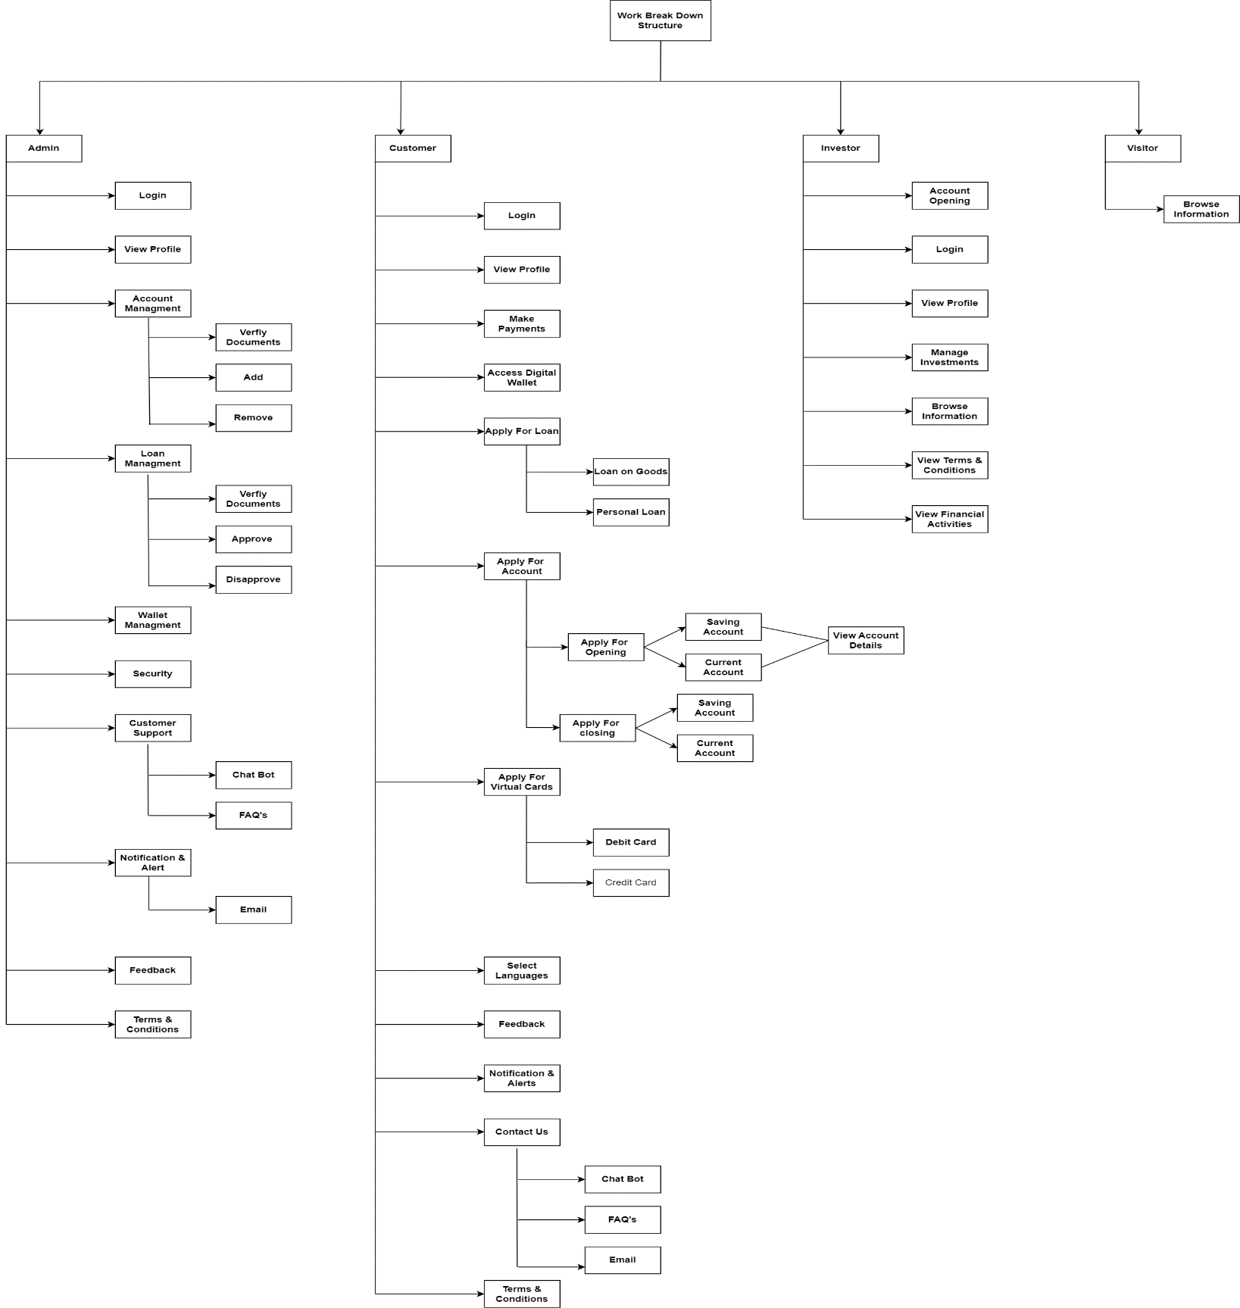We have used deliverable module Work Break Down in our project.

## 3.3.2 Gantt Chart :

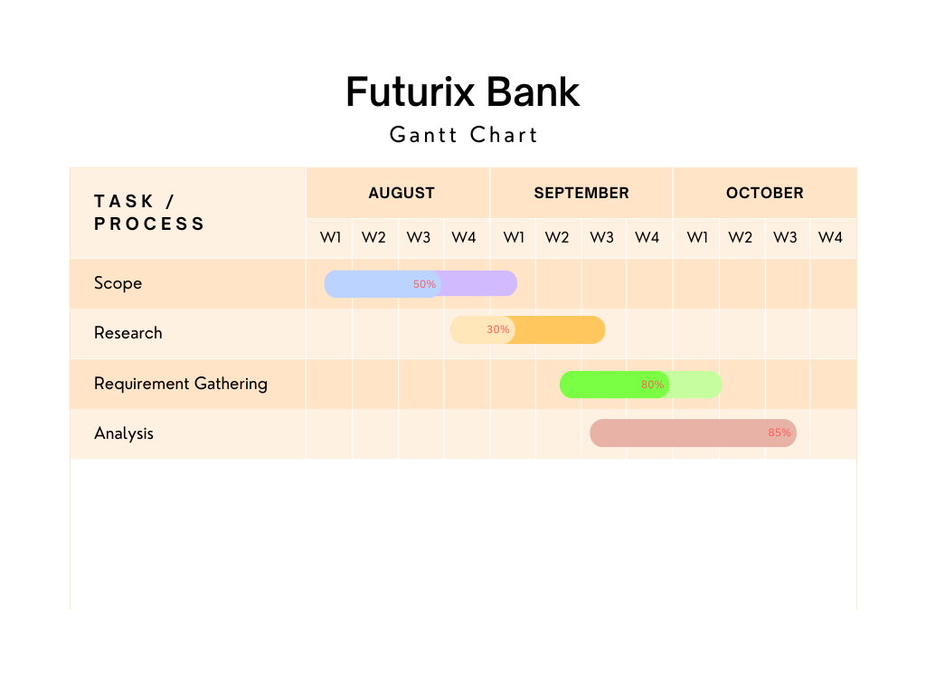

# 3.4 Process Model

## Incremental Model